EUROPEAN COMMISSION
DIRECTORATE-GENERAL INFORMATICS

Directorate B - Digital Business Solutions
DIGIT B3 - Reusable Solutions

EU-FOSSA 2
D3.3 Hackathons Summary

TABLE OF CONTENTS
1 Introduction 3
1.1. Purpose of the document 3
2 Three Hackathons 4
1.2. Purpose 4
1.3. Invited open source communities 4
1.4. The programme 5
1.5. Hackathon Results 5
2. Lessons learned 6
2.1. Main benefits of organising the hackathons 6
2.2. Recommendations to obtain more benefit 7

Introduction
EU-FOSSA 2 (EU Free and Open Source Software Auditing) was a Preparatory Action no. 26.03.77.06 run during 2017-2020. It was a continuation of the successful EU-FOSSA Pilot Project (26.03.77.02).

Purpose of the document
This document summarises the results from the three hackathons organised by the EU-FOSSA 2 project.

Three Hackathons
In 2019, the EU-FOSSA 2 project organised three hackathon events in Brussels.

Purpose
The primary purposes of the hackathons were to:
- Invite one or more open source communities together with colleagues from the European institutions.
- Get the gathered group to work on their project issues. Ideally, find and fix security vulnerabilities, but not restrict themselves to security bugs.
- Potentially discuss deeper issues such as architectural reviews or debate major or pending features, in short – do those things that such an opportunity would provide.
- Exchange ideas with other OSS communities present at the hackathon

Invited open source communities
Hackathon | Communities Present
6-7 April 2019 | PHP Symfony and API Platform
4-5 May 2019 | 6 Projects from the Apache Software Foundation:  - Tomcat  - Spam Assassin  - Karaf  - PLC4X  - Camel  - Singa
5-6 October 2019 | Eight open source projects from the EU:  - API Gateway (WSO2)  - DSS  - Enterprise Search  - eUI  - Flux TL  - midPoint  - PHP  - Workflow Integration (Camunda)

The programme
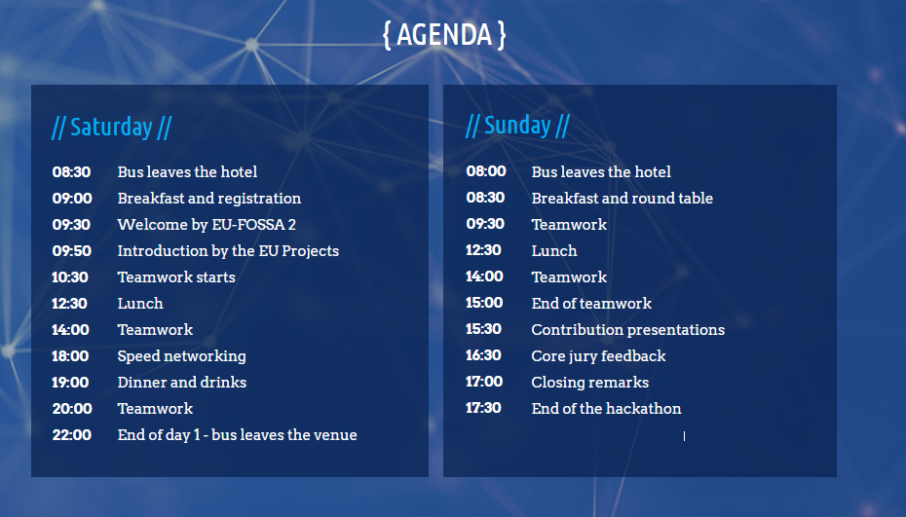

Hackathon Results
These hackathons were considered a success. Many issues were fixed and new features implemented in the software. The feedback received from the invited OSS communities were very positive.
Complete reports of these hackathons are available online at the following websites:
- https://eufossa.github.io/symfony-hackathon-2019/
- https://eufossa.github.io/apache-hackathon-2019/
- https://eufossa.github.io/eu-hackathon-2019/
These reports have been created the "Open Source way", meaning participants contributed to their content through the GitHub platform.
Here is one of the many "thank you tweets" published after the first hackathon:
So proud we took part in the 1st #Symfony #FOSSHackathons in Brussels alongside more than 50 contributors! Thanks for this awesome #EUFOSSA initiative @EU_DIGIT! Feels great to see all these amazing people working together on the future of the #opensource community
- SensioLabs, “Créateur de Symfony”
Here is feedback from another attendee :
“I would like to highlight one most important aspect, the opportunity to gather together our best world-wide community members, was the ultimate bonus we haven't realised first. But now, we are observing the synergies, the new formations arising from Brussels Hackathon, people got introduced and are moving the cooperation to the next level.
Also one of the side-effects, you helped to get midPoint on a map in Europe, the marketing effect, backlinks from mentions are also taking off. The increase in awareness is great.”

Lessons learned
We are presenting hereafter the lessons learned and main benefits of organising these events, and recommendations for the next hackathons.

Main benefits of organising the hackathons
- Direct access to the OSS communities and experts
Core OSS experts are present during the hackathons; EC developers attending the events can discuss complex technical topics with them, ask questions, suggest new features, etc.
- Community and relationship building
The hackathons are an excellent opportunity to build a strong relationship with the OSS communities.
- Opportunity to influence the software development
As explained in the recommendations section below, the hackathons are a good opportunity to influence the development of the OSS projects, request new features or fix major bugs.
- Strong gains in terms of communication and reputation
In general, the OSS communities are very active on social networks and blogs, they communicate easily and quickly through these channels, where they may thank the EU institutions for organising the hackathons, for instance.
- Fast and efficient software implementation
Bringing together core developers has an important impact on productivity; sharing ideas and discussing complex topics is much easier when developers meet in person. This allows fast and efficient software development.
- Security improvements
Security issues can also be discussed in person and fixed during the events, above all if the OSS security team is present.

Recommendations to obtain more benefit
Here are recommendations to better benefit from those events in terms of software implementation.
- Business requirements are clear and validated
It is not in the scope of a hackathon to define business needs. If a new feature is requested by the EC, these needs must be clearly defined beforehand. This will allow developers to focus on the implementation.
- There is a single point of contact or liaison officer within the EC
A technical resource working for the EC is available, has a good knowledge of the OSS project and ideally has already contacts with the OSS community. He acts as a SPOC and organises the hackathon with the community (in terms of technical implementation).
- Features and issues are proposed before the hackathon
In general, OSS projects are managed publicly on OSS platforms, such as GitHub.
New features to be implemented or major bugs to be fixed should first be proposed there, discussed and analysed with the OSS core team members. It is a unique opportunity to refine and validate the technical details with the experts. Code patches can even be submitted before the hackathon and improved during the event.
Obviously, security issues should be discussed in private. In any case, it is recommended to manage this process via the tools commonly used by the OSS project.
- For new features, the scope and destination of the code are agreed upon
If a new feature is requested, it is important to agree on where in the existing codebase this feature will take place. The OSS community may accept to integrate it in the main project codebase, or may prefer to implement it as a module, plugin or external component, outside of the main codebase. In the first case, typically the new code will be 'officially supported' by the OSS project maintainers, while in the second case, it will be up to the EC and/or other contributors to maintain it. Ideally these questions should be clarified before the implementation.
- Issues are easily identified
To better organise the work during the hackathon, issues should be labelled beforehand so they are clearly and easily identified. For instance, GitHub issues and 'pull requests' that were worked on during the first PHP Symfony hackathon had been labelled 'EUFOSSA Hackathon', so developers could quickly find them. As a bonus, the impact in terms of communication and reputation should not be underestimated (i.e. these labels are still publicly visible on the platform).
- The hackathon is organised as a 'code sprint' or 'contribution sprint'
A 'code sprint' or 'contribution sprint' is a specific hackathon format where all developers come together to work on the same OSS project. There is no competition nor prize; participants collaborate and share ideas to improve the project. These 'sprints' are commonly used by OSS communities to progress faster or tackle complex issues. Some sprints can focus on a specific topic (e.g. security) or feature, sub-component, etc.
In general, major OSS communities already have the necessary know-how in organising these sprints. In such case it is recommended to simply follow their procedures. There are important requirements though: for the event to be productive enough, invited participants should already have a strong technical knowledge of the existing codebase, and core team members should be present. For instance, the +/- 50 main Symfony contributors were invited to the first hackathon, during which hundreds of issues were handled.
- EC developers are present during the event
Even if not mandatory, the participation of EC developers during the event is highly recommended, as it allows knowledge transfer, technical review of EC-developed code and community building. It also sends a positive message to the OSS community, which always welcomes contributions.
It is mandatory though if requested features are too specific or require EU-related technical expertise (e.g. integration with EC specific software).
- Follow-up is done after the event
Even if the planned features are delivered during the event, follow-up will be needed to ensure that proper QA is done and outstanding issues are closed. The developers may also decide to postpone some tasks, or proceed to some refactoring. In any case, the EC SPOC should have enough time to do the necessary follow-up, while EC developers could continue working on improving the code.

See e.g. https://eufossa.github.io/symfony-hackathon-2019/tweets.html

