Towards the freedom of the operating system: The French Gendarmerie goes for Ubuntu
Quick facts
Name | Gendarmerie Nationale
Sector | Public
Start date | 2008
End date | N/A
Objectives | Migrate all Gendarmerie workstations From Microsoft Windows to Ubuntu GNU/Linux
Target group | Police stations nation wide
Scope | National
Budget | N/A
Funding | National
Achievements | About 5000 workstations migrated. Significant savings on license costs.

In 2001 the Gendarmerie Nationale, France's national police force, started introducing open source software. The main goals were to gain greater independence and flexibility than proprietary software could offer. The decision to migrate all new workstations to Ubuntu, taken in January 2008, was the most important step in this transition so far.

Table of Contents
Introduction 1
Organisation and political background 3
Budget and Funding 3
Technical issues 4
Legal issues 5
Effect on government services 6
Cooperation with other public bodies 6
Evaluation 6
Achievements / Lessons learned 7
Future plans 8
Links 8

Introduction
The French Gendarmerie Nationale (national police) is composed of the police forces and the military police. The police work of the Gendarmerie includes everything from criminal investigation to airport security and support of military services.It is one of Europe's largest public bodies, having well over 100.000 employees distributed all over the country. Decisions are made in Paris, where the headquarters are situated, which allows fast processes of implementation and problem solving. Nonetheless, this very large institution requires a smoothly operating information and communication infrastructure that does not depend on third parties.
In this respect, a group of experts from the Gendarmerie developed a plan that eventually led the Gendarmerie to abandon Microsoft Windows in favour of the Ubuntu GNU/Linux distribution.
As a first step in this process in 2001, a core team of IT experts around Technical Architect Pascal Danek, and his colleagues Mr. Hamel and Mr. Protet Guillaume decided that it would be necessary to make the IT system more modular. This would allow more flexibility and make the introduction of new standards easier. Already then the group realized that open source software would meet their needs in the most appropriate way, as it offered greater transparency and was easier to adapt and change.
In 2005 the Gendarmerie took another step towards free software. As the first great software transition the office suite Microsoft Office was replaced by the open source counterpart OpenOffice, which not only was available at no cost, but also allowed for exactly this modularity and transparency the Gendarmerie required. Pascal Danek describes the desire for independence from any one company “We didn't want any of our software to force us to employ a special operating system”.
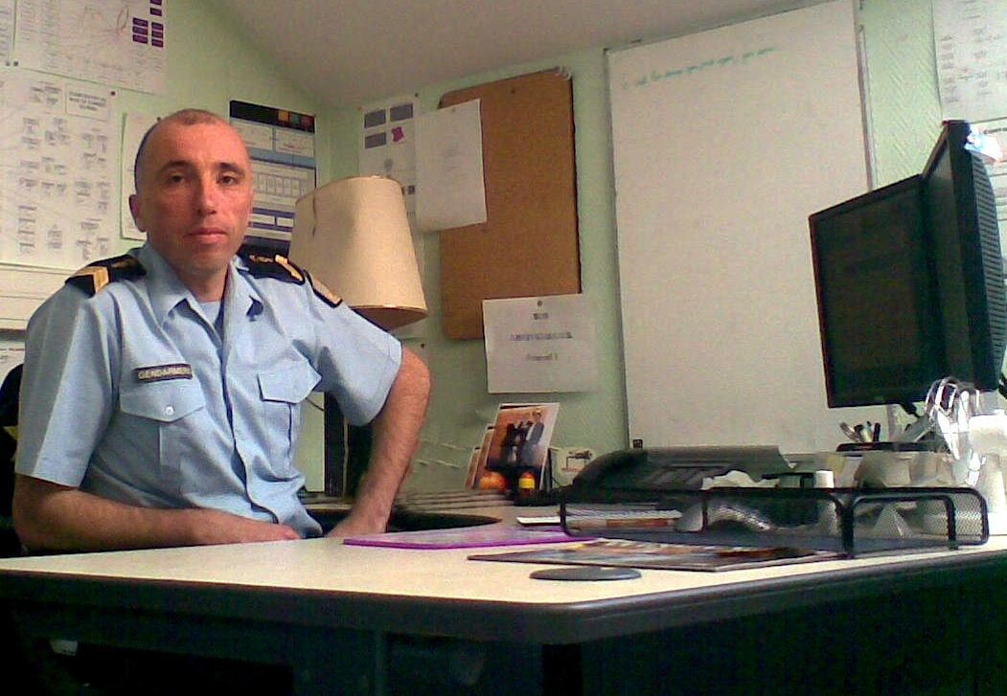Pascal Danek, System Architect at the Gendarmerie Nationale
In the following year the “next step towards the freedom of our computer system”, Danek says, was taken, as one-by-one Microsoft Internet Explorer and Microsoft Outlook were replaced by Mozilla's Firefox web browser and Thunderbird email client.
When Microsoft announced its new operating system Vista in 2006, it became clear for the Gendarmerie that at some point in the near future, a migration of not only applications but also the whole operating system would be necessary. The circumstances were right: Not only had the group gained considerable expertise in working with open source software through the several projects implemented since 2001, but the desktop usability of several GNU/Linux distributions had also significantly improved since that time. The choice which direction to take – Vista or a version of GNU/Linux – was therefore not very difficult. “[For us]keeping the capacity to choose is very important”, as Danek quotes Colonel Nicolas Géraud, deputy director of the Gendarmerie's IT department, with regard to the openness and flexibility of Open Source operating systems. Since many programs were already open source based, and more importantly the servers were already running on Debian GNU/Linux, the Gendarmerie started to develop a plan for the migration to the Debian-based Ubuntu GNU/Linux distribution. Eventually the French Department of Defence supported this decision by putting a moratorium on the implementation of Vista.
When the plan was made public in January 2008, both the open source community, as well as Microsoft paid a a lot of attention to it. As the Gendarmerie is one of the largest public institutions in France, the decision to migrate all their workstations to a free software operating system could not be ignored by either community. The public only learned about the Gendarmerie's plans then; even Canonical Ltd., which is the main commercial sponsor of Ubuntu, were only informed two days ahead of the announcement, as Canonical's Ubuntu Server Product Manager Nicolas Barcet says.
In the year 2008 alone 5000 new workstations have been deployed, all running on Ubuntu. Every new workstation will ship with the same setup. During 2009 the Gendarmerie is planning to migrate close to 15.000 workstations in total.

Organisation and political background
The Gendarmerie Nationale is subject to supervision of the French Ministry of Defence until January 1, 2009. From then it will be subordinated to the Ministry of the Interior.
Like most institutions in France the Gendarmerie is a very centralized organisation, which allows for decisions to be made rather quickly. Especially with regard to the IT system, this has the advantage that workstations can be set up and administrated homogeneously, which in turn makes system administration more efficient. The IT Direction in the Gendarmerie is administered by two officials, who not only are in charge of the information technologies (the workstations, etc.), but also of the general communication system within the organisation. They directly report to the National Director of the Gendarmerie and advise him on those fields.
With regard to the Ubuntu migration process, a small team of five to ten people - the Bureau Securité Architecture - around Pascal Danek and his colleagues, was in charge of developing a plan for the migration to a new OS. The team started working in the late 1990s. Their proposals were essential in the path the eventually led to the decision to migrate to Ubuntu.

Budget and Funding
There is no dedicated budget specifically for the Ubuntu migration process. The financial means for the acquisition of new workstations and the administration of existing ones therefore have not changed, and most probably will not do so in the future. Moreover the Gendarmerie estimates dramatic savings from using free open source software that amount to nearly 7 million Euros per year.
In contrast to several other operating systems, Ubuntu in most cases does not require new hardware components with higher specifications, and can run on even the older machines deployed in the Gendarmerie without significant problems. Danek speaks of a “soft migration”, where new computers come shipped with the necessary installations and old ones gradually can be adapted to this setup.
The initial migration process was thus tackled without additionalfunds. To support the system in the long run, the Bureau Securité Architecture has decided to contract a commercial partner to give advice to technical issues on a high-level. For this, a public tender has been started, which is a necessary step according to French law. At the moment Canonical Ltd., which is also the potential partner in the future, is giving this support at no costs, as the project is both important and interesting to them. So far, there is no information available as to how high the budget for the third party support will be, as the final decision in the public tender has not been made at the time of this writing.

Technical issues
The planning process of developing a standard workstation that would run on Ubuntu, and include all the programmes and applications necessary, required careful consideration of several factors.
The team in charge started with the questions: What do we need? Which applications are Microsoft dependent, and which are compatible with Ubuntu? Where are those workstations deployed? These were addressed in a study that aimed at mapping out a plan for a standard workstation, which would suit the needs of the Gendarmerie in all ways. After this study was finalised in mid-2007, a total of 35 applications were found to be essential for a standard workstation.
The choice for the Ubuntu distribution was mainly based on the existing expertise that the team had gained from administrating the Debian GNU/Linux based servers. Since Ubuntu is also based on Debian, the team was able to apply their existing knowledge to the new system. The user friendliness of the Ubuntu user interface further supported their choice, as it made the transition from Windows 2000/XP to Ubuntu on the desktop relatively easy.
Since many applications remained the same and could run perfectly on Ubuntu (i.e. OpenOffice, Firefox), or were web-based, the transition process to the new operating system did not pose many technical difficulties. Although a number of problems did occur, compatibility with the open source operating system was not generally an issue. As an example of an obstacle in the process, Danek mentioned the shared calender function of Microsoft Outlook, which was heavily used in the administrations of the Département, for which it proved more difficult to find a counterpart compatible with Ubuntu. Nonetheless a solution was found at some point, which in this case was presented by OBM (Open Business Management), an application that could replace, at least to a large extent, functions of MS Outlook. Eventually, the Gendarmerie hopes to be able to fully move away from Windows applications at some point. The goal for the year 2009 is the migration of up to 15.000 workstations to the new operating system.
From an end-user perspective, the transition went unexpectedly smooth. Almost no additional training was required for the local police forces using the computers in their daily work. This was in part thanks to the fact that the software applications remained the same, but also because the Ubuntu user interface was easy to get used to.
Pascal Danek points out that a transition from Microsoft Windows 2000/XP to Vista would have been more difficult, since the new version of that operating system introduces many new features and designs which might confuse users. If difficulties do occur, there is however a Didacticien, which is a tutorial application installed on each workstation that can give further guidance if problems occur. Furthermore, there is a hotline that the local police stations can call where phone guidance on technical issues is given. This helpline however is not used very often, as most issues can be resolved in a learning by doing fashion.

Legal issues
For the decision to migrate to Ubuntu, no legal steps had to be considered, as this was an internal affair which did not involve additional costs. Nonetheless the French law requires certain legal procedures when commercial partners are contracted at an additional costs to the state. With regard to the Ubuntu project, this was the case for the external support from the private sector. The Gendarmerie is thus obliged to take the following steps:
- Creating a public tender, where all requirements and specifications are clarified
- Sending it to the public tender bureau
- Publicising the tender
- Waiting for possible commercial partners to respond
- Selecting the most appropriate partner
The winner of this tendering process is expected to be announced in early 2009.

Effect on government services
Through the introduction of Ubuntu, the networking abilities of the local police stations and the central office in Paris has improved very much. The cache of each workstation is saved on the network, which allows on the one hand for work to continue (or be recovered quickly) when a station crashes, but also when it is simply shut down. This improves daily work to a significant extent, as documents can be obtained much easier at any time, and from nearly everywhere.

Cooperation with other public bodies
While none of the people interviewed for this case study mentioned a cooperation with other public bodies on the migration to open source, the project is one of several similar migrations of French public bodies. To mention just a some examples: the French National Assembly in 2007 decided to run Ubuntu on their 1145 workstations; the Ministry of Agriculture and Fishery switched their servers to the Mandriva GNU/Linux distribution in 2005; the Paris council will use several open souce applications on their laptops, as decided in June, 2008. These developments thus clearly show how open source software is used increasingly in the French public sector.
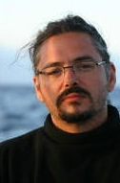Nick Barcet, Ubuntu Server Product Manager at Canonical
The Gendarmerie is already cooperating with Canonical, even though there is no formal contract. Canonical sees the scale of the project as an ideal situation to get feedback about their product. This unofficial cooperation started only in June 2008. Canonical is currently not providing support to end users. The company will only work together closely with a small group of 10 to 20 people within the core IT team of the Gendarmerie. At the moment the contact is limited only to Pascal Danek and a few colleagues of his.

Evaluation
Since the beginning of the project in 2001, there have been many developments towards the present migration of the operating system. The migration process therefore has to be considered within the context of earlier developments. Nick Barcet highlights the careful planning of the Gendarmerie's every step in the migration to open source software as an essential ingredient for success in this project. To recall once more, these developments were as follows:
- From 2002 to 2004 the Gendarmerie created a more centralized architecture by putting all applications on the Intranet, which also allowed for greater modularity
- In 2005 the decision to replace Microsoft Office with Open Office was made
- Not much later, Mozilla's web browser Firefox and email client Thunderbird were introduced
- After the announcement of Windows Vista in late 2006, the decision was made to migrate to Ubuntu.
Compared to other project that Danek has experienced, “addressing the problems one by one” proved to be much more effective than a “hard migration”, replacing all operating systems at the same time, he says.
He states that there have not been any complaints or reports of significant difficulties from end users so far. However, as the project has only started in 2008 and only 5000 machines are running on Ubunut until now, no definite answer can be given in this respect. Danek further reports that there is a lively exchange between the headquarters and the Départments, which would enable them to react to problems rather effectively. A conference was held in Paris in early October 2008 where not only officials were invited to discuss the IT infrastructure, but also local officers had the chance to express their opinions. For Danek, these hands-on experiences provided very important feedback, as this went beyond official assessments of the project. He concluded “We think we have a good view on what the problems are and I think that it's very positive a the moment”.
From a financial point of view, Barcet is well aware of the costs of migrating a whole system, as “the costs of migrating always exceed the status quo”. Nonetheless he argues that it is important to look at the costs in the long run, and compare those to alternatives. Here, a migration to Windows Vista would by far have exceeded the costs of the Ubtuntu migration, as not only hardware updates would have been necessary, but future software updates involving costly licenses would further add to the bill. Since GNU/Linux has relatively low hardware requirements, can run even on older machines without problems, and can be obtained free of charge, the costs of such a solution can be lower. Moreover, the GNU/Linux command line interface has remained fairly stable for the last 10 years, letting administrators continue to use the knowledge they have acquired in the past..

Achievements / Lessons learned
The migration of the first 5000 workstations has been accomplished successfully, according to Danek. Besides a few pending issues, “there is no big problem remaining in our IT system with regard to Linux”, he states. The openness of the GNU/Linux platform offers the Gendarmerie the possibility to constantly adapt and improve their system according to their needs, which brings many advantages compared to other operating systems.
For Ubuntu's Nick Barcet the project is a very important and unique source of feedback. As there are only very few ventures in these dimensions, the insights gained here can be essential for the further development of Ubuntu in the future. As one example of this, Barcet mentioned an issue the Gendarmerie had with Ubuntu's Update Manager that required administrator rights, which were not available to every user. Canonical was thus contacted by the Gendarmerie about this issue, and a solution was found. Especially for larger institutions and organisations this was important, as the occurrence of the same problem could be avoided in the future. The cooperation of Canonical and the Gendarmerie is therefore mutual beneficial.

Future plans
For the future Pascal Danek says, the team will try to resolve the few remaining issues in the migration process, such as problems related to the Samba file server application.
He and his colleagues are optimistic about migrating all of the Gendarmerie's desktops to Ubuntu by 2015. They believe that this will not only dramatically improve the force's IT systems, but save large sums of money that otherwise would have been spent on licenses.

Links
- Parlez-Vous Ubuntu? - Says the French Police
- Canonical
- La Gendarmerie Nationale
- La gendarmerie passera ses 70 000 PC sous Ubuntu d'ici à 5 ans
- La gendarmerie française met Windows au trou
- Paris council laptops to use Open Source
- Ministry of Agriculture and Fishery switches servers to Linux
- Parliament selects Ubuntu Linux for desktop




This case study is brought to you by the Open Source Observatory and Repository (OSOR), a project of the European Commission's IDABC project.
Author: Gregor Bierhals, UNU-MERIT
This study is based on interviews with Pascal Danek, technical architect at the Gendarmerie Nationale; and Nick Barcet, Ubuntu Server Product Manager at Canonical.

