2016-03-15
Working Group meeting on Core Criterion and Core Evidence Vocabulary (CCCEV)
Virtual Meeting 2
SEMIC Phase 7
Meeting Minutes

Webinar: Core Criterion and Core Evidence Vocabulary
Venue | Adobe Connect | Meeting date | 2016-03-15
Author | Stefanos Kotoglou | Meeting time | 10:00 – 11:30
Reviewed by | Oriol Bausa Peris | Issue date | 2016-03-18
Status | For review | Version | 0.01

Attendees
Name | Abbreviation | Organisation
Enric Staromiejski | ES | Everis
Giampaolo Sellitto | GS | Autorita Nazionale Anticorruzione (Italy)
Irina Svensson | IS | Swedish national procurement agency
Loukia Demiri | LD | Hellenic Ministry of Interior and Administrative Reconstruction (Greece)
Makx Dekkers | MD | Freelancer
Nikolaos Loutas | NL | PwC EU Services
Oriol Bausa Peris | OB | Invinet
Raf Buyle | RB | Flemish Information Agency (AIV)
Stefanos Kotoglou | SK | PwC EU Services
Timo Rantanen | TR | Hansel
Vassilios Peristeras | VP | ISA Programme, European Commission
Veronique Volders | VV | Agency for Local Governance

Agenda
ID | Description
 | Introduction of new participants – tour de table
 | Minutes from last meeting (Stefanos)
 | Appointment of chair (Nikos)
 | Overview of the specification (Oriol)
 | Core Criterion and Core Evidence Vocabulary – Draft 1 (Oriol, All)
 | Open issues
 | Next steps (Oriol)

Introduction of new participants – tour de table

OB invited everyone to make a self-presentation, providing more information about their organisation.

Participants provided information about their organisations. The following table provides an overview of the received input:

Table 1 Round table
Abbreviation | Description
ES | Working at DG GROW. He drafted and proposed the 1st data model of the vocabulary.
GS | Working for Autorita Nazionale Anticorruzione. They are focusing on e-procurement, and specifically on evidence and criterion.  They want to apply it to their system.
IS | Working as a procurement lawyer for the Swedish national procurement agency
LD | Working for the Hellenic Ministry of Interior and Administrative Reconstruction.
MD | Working on developing other specifications (e.g. StatDCAT-AP). Makx will be providing support to the editor of this work.
NL | Working for Working for PwC, and assisting the editor of CCCEV. He is the project manager, assisting the EC.
OB | Oriol has previous experience in developing core vocabularies. He will be the editor for this work.
RB | Working for the Flemish Information Agency (AIV)
SK | Working for PwC, and assisting the editor of CCCEV.
TR | Working for Hansel - the central procurement body for Finnish Central Government. They are implanting e-tendering and other e-procurement tools (excl. e-Invoicing and e-Payment) for the Finish central government
VP | Programme Officer of ISA and responsible for the SEMIC project.
VV | Work for a Flemish agency. Program manager of the digital operations. Interested in exploring the semantic of local decisions and e-procurements.

Minutes from last meeting (Stefanos)
SK informed the participants that the meeting minutes from the last meeting are available online for review.

Appointment of chair (Nikos)
GS presented himself:
GS is working for Autorità Nazionale anticorruzione (ANAC) in Italy. He is also involved in e-SENS EU project (semantics and semantic mapping) and in CEN BII 3 workshop.

More information about GS in the PowerPoint presentation:

Overview of the specification (Oriol)
OB presented the scope of this work by drawing attention on the two basic core concepts of the CCCEV:

Criterion
Something that is used as a reason for making a judgement or decision, e.g. a requirement set in a public tender or a condition that has to be fulfilled for a public service to be executed; and

Evidence
Something which shows that something else exists or is true, in particular an evidence is used to prove that a specific criterion is met.

OB presented the uses cases that have been developed:

Facilitate development of interoperable information systems
- The CCCEV allows systems to seamlessly exchange information about criteria and evidence related not only to public procurement development but to the provision of digital public services in general.
Create a repository of reusable criteria in machine-readable formats
- The CCCEV enables the creation of a repository of criteria and evidences which can be reused in different public procurement cases and digital public services.
Automate the assessment of criteria
- The CCCEV can help e-Government and e-Procurement systems to easily compare the information collected from different parties and enables automatic assessment of the responses to a specific criterion.
Automate scoring of responses
- Taking the previous scenario one step further, by assigning weights to criteria, the assessment can be followed by an automate scoring of the responses provided by different parties.
Promote cross-border participation in public procurement
- The CCCEV allows for removing language barriers improving the cross-border exchange of information, and thus the cross-border participation in pan-European selection processes.
Calculating statistics
- By standardising data for criterion, criterion responses and evidences public administrations, auditors and independent organisations can calculate statistical information on the most common used criteria for a given process, the most relevant evidences, etc.
Create a registry of mappings of criteria and associated evidences
- Using the CCCEV, it will be possible to create a registry of mappings to allow crosschecking of the criteria with the evidences applicable in different Member States.

OB presented a draft list of the information requirements. In total, 45 requirements have been defined for the CCCEV:

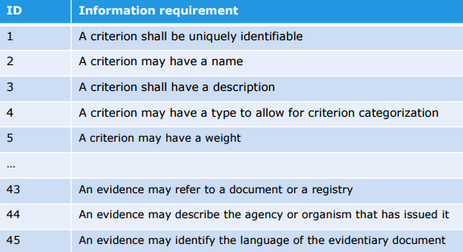
Figure 1 Information requirements
NL mention that the full list of the information requirements is available in the first draft of the specification.

NL invited the participants to review the specification, and provide their feedback via the mailing list or the issue tracker.

Core Criterion and Core Evidence Vocabulary – Draft 1 (Oriol, All)
OB mentioned that for the first draft of the vocabulary, we have:
- identified related data standardisation efforts
- used the ESPD conceptual data model as a basis
- taken into account:
  - discussions within the eSENS VCD group;
  - considerations from the UBL TC; and
  - CCCEV Editor

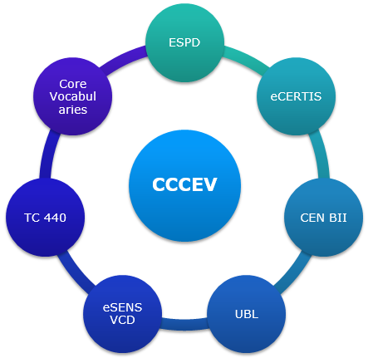
Figure 2 ecosystem of CCCEV
OB invited the participants to identify and suggest more data models and data standardisations to be taken into consideration on the development for the vocabulary.

ES suggested broadening the working group by inviting more people who are participating in similar projects.

NL mentioned that the work is communicated via:
- ISA representatives;
- DG GROW; and
- Various mailing lists.

ES mentioned that the vocabulary should be generic and simple for enhancing its re-usability.

OB presented the two versions of the data model that have been developed so far. The first version (Figure 3) was presented during the first virtual meeting of the working group.
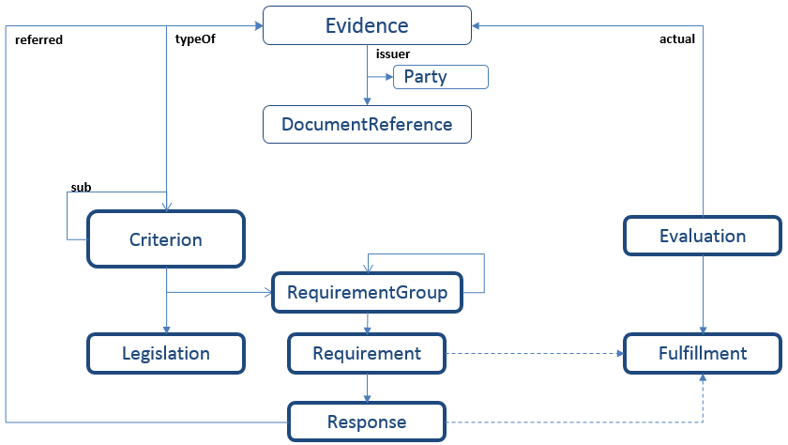
Figure 3 First version of the data model
The second (Figure 4 - updated version) was presented during the second virtual meeting. This version was developed in collaboration with the members of the working group.
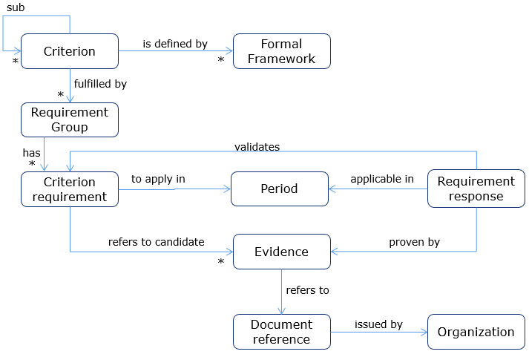
Figure 4 Second version of the data model
ES explained that “Requirement Group” is a set of for specifying and indicating how the criterion is fulfilled. ES provided an example:
“A contracting authority is asking from the economic operator to provide information about the turnover of the last three years. The turnover of each year is a sub-requirement.”

ES mentioned that DG GROW has already provided some XML examples for facilitating the understanding of classes and properties.

NL suggested developing and including in the specification:
- two human-readable examples in the specification; and
- definitions of the concepts.

MD recommended formulating the requirements in such a way that the criterion stays separated from the requirement.

ES mentioned that it would be feasible using definitions from the ESPD model for CCCEV.

ES mentioned that in ESPD there is lack of definitions, but on the other hand there is a document with data-flows, examples and a glossary.

OB proposed redrafting the data model based on the discussion of the ESPD group.

NL mentioned that the starting point for updating the data model is the ESPD model, and he invited the participants to make proposals and other deviations.

Open issues
OB informed the participants that the first issues have been added to the issue tracker, and he invited the participants to provide their comments.

Next steps (Oriol)

ID | Description | Owner | Due date
 | To share the first draft of the vocabulary with the working group | Editors | Done
 | To share the slides and the minutes from the meeting | Editors | Done
 | To share the glossary with the editors for further developing the draft of the vocabulary. | ES | 23/03/2016
 | To review the specification, and provide their feedback via the mailing list or the issue tracker | WG | 15/04/2016
 | To provide examples of the use of the CCCEV for facilitating the understanding of classes and properties | Editors | 15/04/2016

Chat log

