D02.02 – Minutes of Meeting – Working Group Webinar I
Action 1.3 Catalogue of Services Specific Contract under Framework Contract DI/07171 – Lot 2
Project: | Action 1.3 Catalogue of Services | Meeting Date/Time: | 03/11/2014 – 14:00-16:00
Meeting Type: | Webinar | Meeting Location: | Online
Meeting Coordinator: | Miguel Alvarez-Rodriguez | Issue Date: | 04/11/2014

Attendee Name | Initials | Organisation/Country
Eduards Cauna | EC | Latvia
Liene Strazdina | LS
Marcin Kraska | MK | Poland
Andrzej Jarzewski (excused) | AJ
Jaroslaw Tomaszewksi (excused) | JT
Niina Etelavuori | NE | Finland
Jarmo Kovero (excused) | JK
Konstantitas Peciulis | KP | Lithuania
Antonis Stasis | AS | Greece
Loukia Demiri | LD
Manuel Mateos | MM | Spain
Patrocinio Nieto (excused) | PN
Peter Reichstaedter (excused) | PR | Austria
Franz Grandits (excused) | FG
Mihkel Lauk | MV | Estonia
Miguel Alvarez-Rodriguez | MA | ISA, European Commission
Peter Burian | PB
Vassilios Peristeras | VP
Agnieszka Bajno | AB | DG MARKT, European Commission
Eleni Panopoulou | EP | Freelancer
Nikolaos Loutas | NL | PwC EU Services
Michiel De Keyzer | MDK
Sebastiaan Rousseeuw | SR

Meeting Agenda
- Round-table and collaboration in the working group (25’)
- Context and discussion (35’)
- Common working terminology of key concepts (20’)
- First results of analysing the PSCs (20’)
- Next steps (5’)
- Q & A (5’)

Presentation: https://joinup.ec.europa.eu/node/104629

Summary of Meeting
Topic | Summary
Round-table and collaboration in the working group | - MA gave a welcome to the working group and explained its high-level objectives.  - The attendees (see list above) introduced themselves stating their organization and function. There was no representative from Austria present in the webinar.  - MDK explained the different collaboration tools that will be used in the working group. The people who were not yet subscribed to the mailing list (cpsv-ap@Joinup.ec.europa.eu) were added manually. Membership to the project on Joinup can be requested at https://joinup.ec.europa.eu/node/104244/  - Every member of the working group should sign the ISA contributor agreement: https://joinup.ec.europa.eu/node/104627  - MDK explained the process & methodology that will be followed for developing the Application Profile of the CPSV. The work is conducted according to the ISA process and methodology for developing Core Vocabularies: https://joinup.ec.europa.eu/node/43160.  The specification of the CPSV-AP will start following a bottom-up approach (see figure below). PwC has therefore started with reviewing and analysing the state-of-the-art in the MSs concerning the models being used for describing key business events and public services on the electronic PSCs of the Member States. This analysis will lead to the documentation of the classes and properties of each model being used in the Member States.  - The Working Group will be asked to review and validate the analysis of the documented data model for their country.  - Subsequently, these data models will be compared in order to identify differences and commonalities. As a result of this comparison, we will identify possible new classes and properties that may be added to the CPSV-AP and will be suggested for approval to the Working Group.  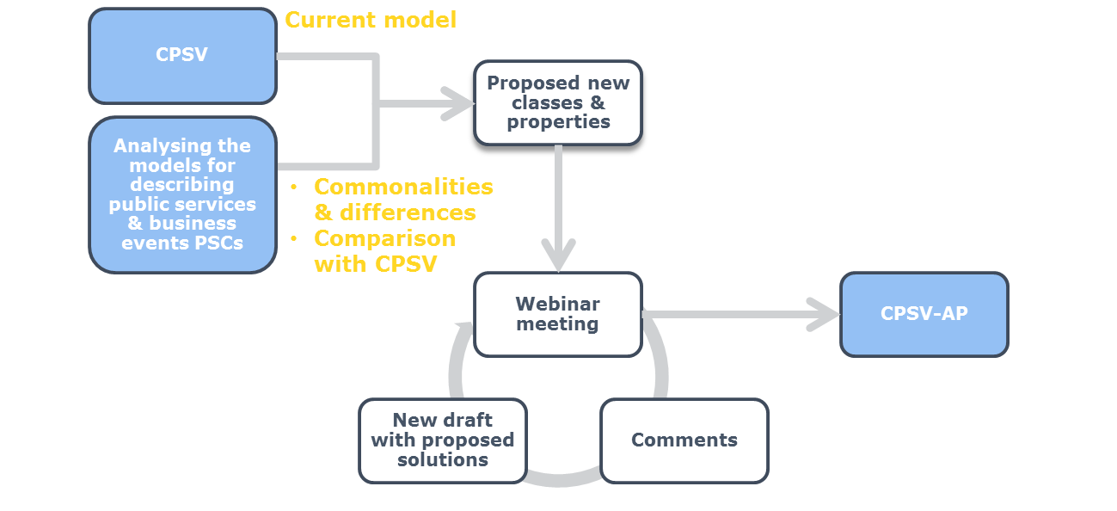
Context and discussion | - MDK presented the challenges identified by the project team that the PSCs in the EU Member States are facing.  - Every attendee shortly described the challenges they face, with particular reference to their country:  - Greece: There are many stakeholders involved, not all of them are using the same data model. It is hard to integrate the different descriptions. There is also no support of multilingualism;  - Latvia: There is a fragmentation of responsibilities for providing public service descriptions. There is no support on multilingualism due to budget restrictions. Each agency is using their own data model;  - Lithuania: There is only one PSC, however descriptions of the Key Business Events and Public Services are provided in different ways in different ways;  - Poland: The idea is to use the descriptions, stored in the single PSC, in different national systems. There are also a lot of institutions and procedures for keeping the information up-to-date, this will become challenging in the future.
Common working terminology of key concepts | - MDK explained the proposal of the common terminology that will be used for the key concepts. The members of the WG are invited to review the definitions by the next webinar (2014-11-19) and share their feedback with the EC. The terminology can be found in section 2 of the first version of the specification of the CPSV-AP: https://joinup.ec.europa.eu/node/107879  - MDK introduced the Core Public Service Vocabulary, i.e. the starting point for creating the CPSV-AP.  - The members of the WG are invited to review the current specifications by the next webinar (2014-11-19). If more information is needed about the current CPSV, PwC can provide clarifications/explanations.  - MK asked what the exact goal is of developing the CPSV-AP. NL explained that in the short term the intention is to create a common data model for describing key business events and public services. NL pointed out that we will also define taxonomies and controlled vocabularies. NL pointed out that we will not define a common list of public services within the context of this WG, but this would be an interesting future direction of ISA Action 1.3.  - ML explained that Latvia and Estonia have the same issue with equivalent public services that are described very differently. This means that there are a lot of duplicate descriptions of public services in the PSCs. ML also pointed out that a common list of public services and agreement on naming conventions are important for Estonia.
First results of analysing the PSCs | - MDK presented the two documents that PwC EU Services is currently working on.  - First the CPSV-AP specifications document was shortly described: https://joinup.ec.europa.eu/node/107361/  - The spreadsheet that was described afterwards contains the first analysis of key business events and public services available in the different country’s PSCs: https://joinup.ec.europa.eu/node/107357/  - The Members of the Working Group are invited to review the first results and provide feedback through the mailing list, by sending an e-mail directly to the project team or by commenting on Joinup.  - MA explained that CPSV-AP can be used for providing mappings of the national models but also other models used within a MS. This model can then be used in other contexts, sectors...
Next steps | - MDK explained what is expected from the members of the Working Group before the next webinar. These actions can be found in the table below.

Action Nr | Action description | Target Date | Action Owner
01 | Review the definitions of the common terminology that will be used for the key concepts (section 2):  https://joinup.ec.europa.eu/node/107879 | Next webinar (2014-11-19) | MS representatives
02 | Review the analysis of the data model(s) to describe business events and public services in the 8 MSs participating in the CPSV-AP WG (section 3):  https://joinup.ec.europa.eu/node/107361/ | Next webinar (2014-11-19) | MS representatives
03 | Get familiar with the CPSV (sections 5) and review the first version of the CPSV-AP:  https://joinup.ec.europa.eu/node/107361/ | Next webinar (2014-11-19) | MS representatives
04 | Review the analysis of key business events and public services available on your country’s PSC (spreadsheet):  https://joinup.ec.europa.eu/node/107357/ | Next webinar (2014-11-19) | MS representatives
05 | Send meeting minutes to the working group. | 2014-11-06 | PwC
06 | Further extend the analysis of the key business events and public services available in the country’s PSCs. | 2014-11-17 | PwC
07 | Collect the feedback and feed it in new versions of the two reports. Share the updated reports with the Working Group. | 2014-11-17 | PwC

